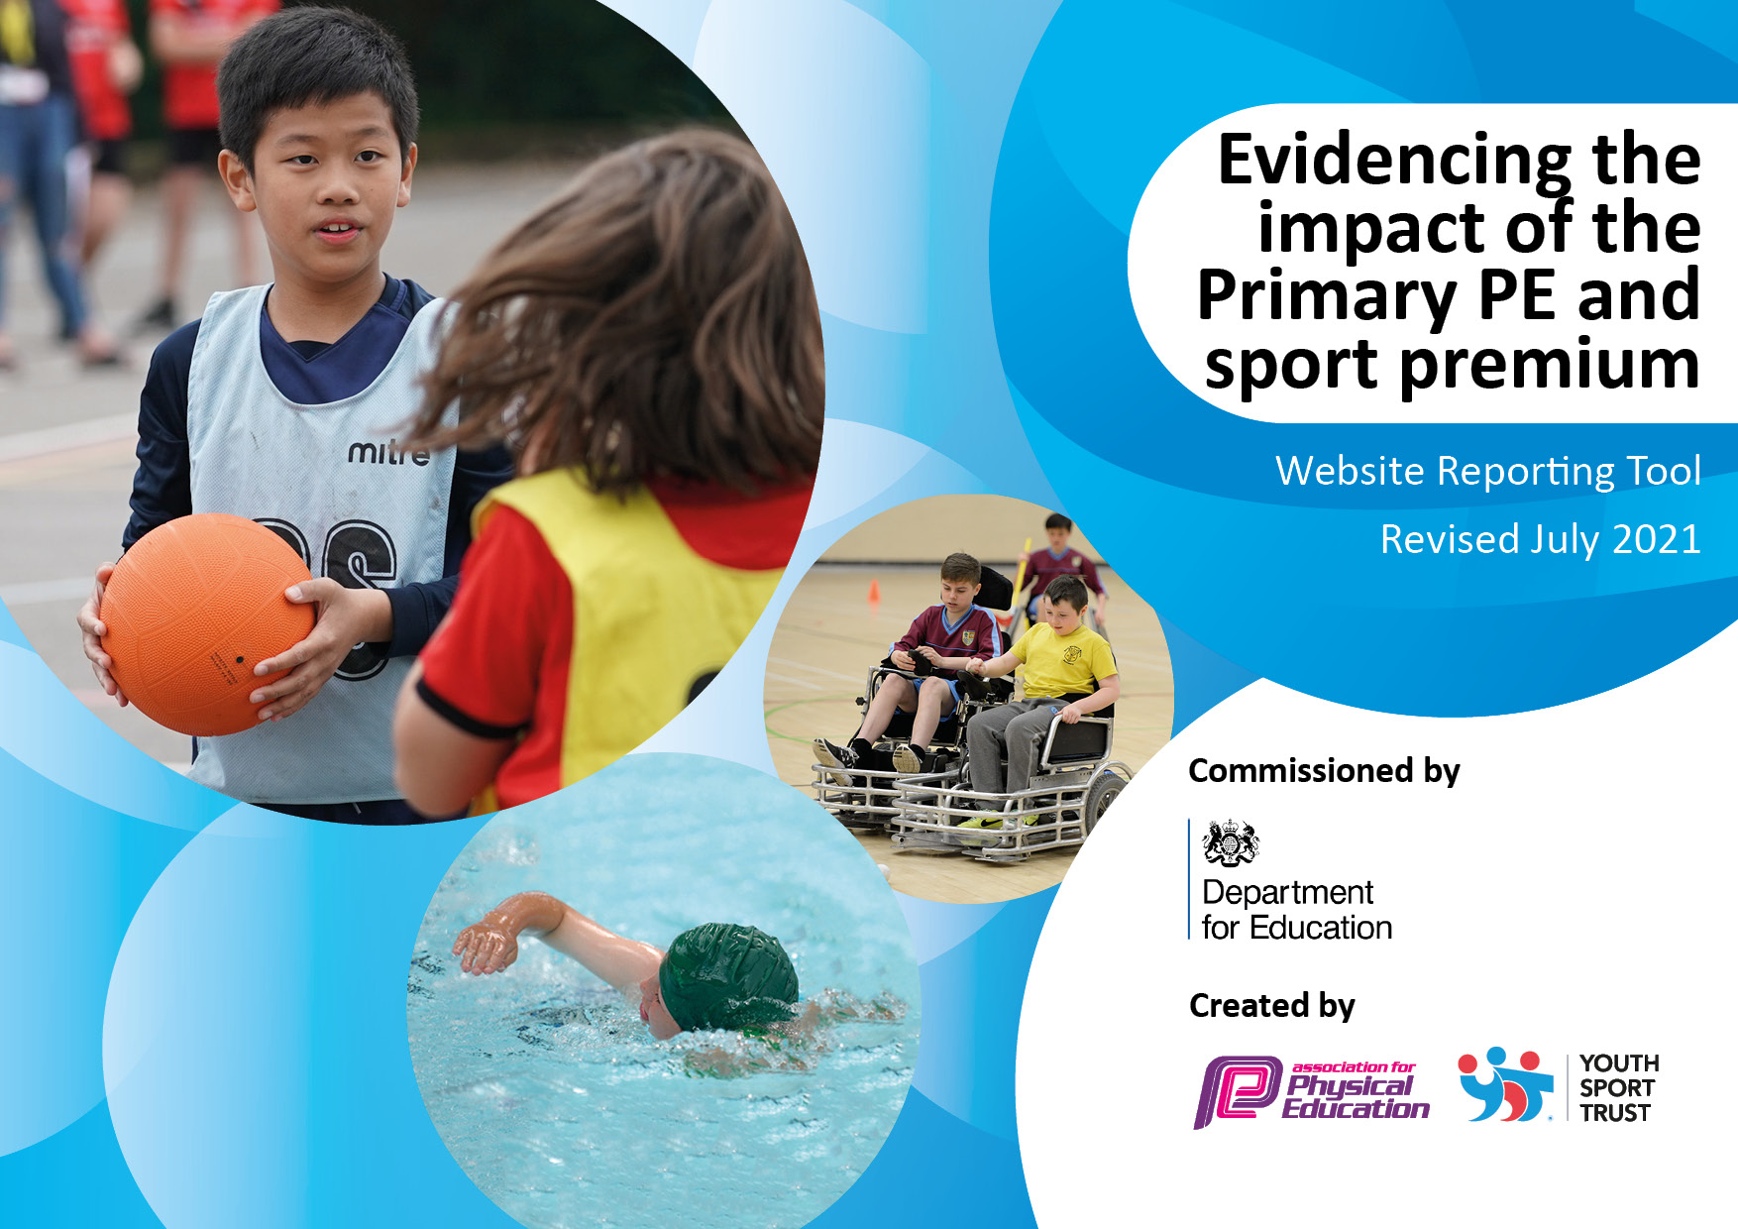
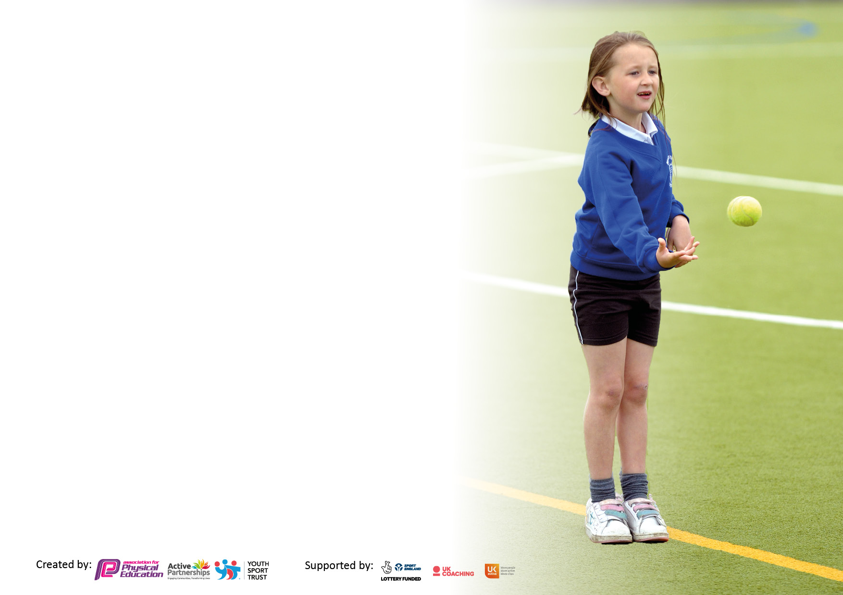

It is important that your grant is used effectively and based on school need. The Education Inspection Framework makes clear there will be a focus on ‘whether leaders and those responsible for governors all understand their respective roles and perform these in a way that enhances the effectiveness of the school’.

Under the Quality of Education Ofsted inspectors consider:
Intent - Curriculum design, coverage and appropriateness
Implementation - Curriculum delivery, Teaching (pedagogy) and Assessment
Impact - Attainment and progress

To assist schools with common transferable language this template has been developed to utilise the same three headings which should make your plans easily transferable between working documents.

Schools must use the funding to make additional and sustainable improvements to the quality of Physical Education, School Sport and Physical Activity (PESSPA) they offer. This means that you should use the Primary PE and sport premium to:

- Develop or add to the PESSPA activities that your school already offer
- Build capacity and capability within the school to ensure that improvements made now will benefit pupils joining the school in future years
- The Primary PE and sport premium should not be used to fund capital spend projects; the school’s budget should fund these.

Pleasevisitgov.ukfortherevisedDfEguidanceincludingthe5keyindicatorsacrosswhichschoolsshoulddemonstrate animprovement.Thisdocumentwillhelpyoutoreviewyourprovisionandtoreportyourspend.DfEencouragesschools to use this template as an effective way of meeting the reporting requirements of the Primary PE and sport premium.

We recommend you start by reflecting on the impact of current provision and reviewing the previous spend.

Schools are required to publish details of how they spend this funding, including any under-spend from 2019/2020, as well as on the impact it has on pupils’ PE and sport participation and attainment. All funding must be spent by 31st July 2022.

We recommend regularly updating the table and publishing it on your website throughout the year. This evidences your ongoing self-evaluation of how you are using the funding to secure maximum, sustainable impact. Final copy must be posted on your website by the end of the academic year and no later than the 31st July 2021. To see an example of how to complete the table please click HERE.

Details with regard to funding
Please complete the table below.

Total amount carried over from 2019/20 | £2,000
Total amount allocated for 2020/21 | £ 17,740
How much (if any) do you intend to carry over from this total fund into 2021/22? | £ 3,000
Total amount allocated for 2021/22 | £ 24,740
Total amount of funding for 2021/22. To be spent and reported on by 31st July 2022. | £
Swimming Data
Please report on your Swimming Data below.

Meeting national curriculum requirements for swimming and water safety.

N.B. Complete this section to your best ability. For example you might have practised safe self-rescue techniques on dry land which you can then transfer to the pool when school swimming restarts.
Due to exceptional circumstances priority should be given to ensuring that pupils can perform safe self rescue even if they do not fully meet the first two requirements of the NC programme of study
What percentage of your current Year 6 cohort swim competently, confidently and proficiently over a distance of at least 25 metres?  N.B. Even though your pupils may swim in another year please report on their attainment on leaving primary school at the end of the summer term 2020.  Please see note above | 64.3%
What percentage of your current Year 6 cohort use a range of strokes effectively [for example, front crawl, backstroke and breaststroke]?  Please see note above | 64.3%
What percentage of your current Year 6 cohort perform safe self-rescue in different water-based situations? | 0%
Schools can choose to use the Primary PE and sport premium to provide additional provision for swimming but this must be for activity over and above the national curriculum requirements. Have you used it in this way? | 6 x 1hr sessions (Summer 2)

Action Plan and Budget Tracking
Capture your intended annual spend against the 5 key indicators. Clarify the success criteria and evidence of impact that you intend to measure to evaluate for pupils today and for the future.

Academic Year: 2020/21 | Total fund allocated: | Date Updated:
Key indicator 1: The engagement of all pupils in regular physical activity – Chief Medical Officers guidelines recommend that primary school pupils undertake at least 30 minutes of physical activity a day in school |  |  |  | Percentage of total allocation:
 |  |  |  | 3,690 = 18%
Intent | Implementation |  | Impact
Your school focus should be clear what you want the pupils to know and be able to do and about  what they need to learn and to  consolidate through practice: | Make sure your actions to achieve are linked to your intentions: | Funding allocated: | Evidence of impact: what do pupils now know and what can they now do? What has changed? | Sustainability and suggested next steps:
1. All children to follow the Skip2Bfit program.  2. All classes to include 5minute active sessions daily.  3. All pupils to be offered daily lunchtime competition.  4. Develop parental involvement in physical activity through the Grab a Grown-up workshops.  5. Promote parent and child physical activity through the Monkey Movers program.  6. Develop young leaders in order to support playtime activity and Skip 2B Fit. (hopscotch, skipping, tag-tig, )  6. Introduce a light reaction board for use at playtimes and lunch times.  7. Whole school activity days to promote physical activity.  Judo  Yoga + Archery  Hula Hooping + Fitness  8. Ensure each class receives at least 2 hours of high-quality PE, following the core task Framework.  9. increase activity levels on a lunchtime  10. Increase activity levels during play time /lunchtimes | Sessions to take place daily from 8.40 – 8.45am.  Daily sessions shown on timetables.  All competitions displayed on PE noticeboard and pupil participation recorded.  Sessions to run Autumn 1 (Y1), Spring 1 (Y2) and Summer 1 (Rec). Adult attendance recorded.  Scheme to run Autumn 1 (Y2), Summer 1 (Y1) and Summer 2 (Rec)  Morning training session for hopscotch and skipping. Hoodies ordered and ready for use in Autumn term.  Board training November and roll out to follow  Judo day (October)  Yoga/Archery (December)  Hula/Fitness (February)  Audit PE equipment and order resources  Play lead employment  OPAL reaccreditation and additional equipment | £350 (new ropes, music and storage)  £0  £600 (netball posts and fitting)  £750 SLA cost  £100 (equipment)  £190 (supply cover) £200 (hoodies)  £4,000 (grant)  £0  £1,500  £3635  £500
Key indicator 2: The profile of PESSPA being raised across the school as a tool for whole school improvement |  |  |  | Percentage of total allocation:
 |  |  |  | £1830 = 9%
Intent | Implementation |  | Impact
Your school focus should be clear what you want the pupils to know and be able to do and about  what they need to learn and to  consolidate through practice: | Make sure your actions to achieve are linked to your intentions: | Funding allocated: | Evidence of impact: what do pupils now know and what can they now do? What has changed? | Sustainability and suggested next steps:
1. Further improve behaviour and attitudes through the 6 sporting values, linked to the school values program.  2. Improved behaviour at playtimes and lunchtimes, through sporting competition and Young Leader led activities.  3. Greater home-school and community links, through Grab a Grown-Up, Monkey Movers, cluster leagues and termly PE newsletters.  4. Improved behaviour at break and lunch-times. | Ensure all staff have certificates. Weekly presentation of awards in celebration assembly. Links made in PSHCE lessons.  Lunchtime program developed and led by Mr Walker. Young leaders trained and allocated daily slots hopscotch – au1  Skipping – au 2  Grab a Grown-Up letters sent out Autumn 1 and parent participation recorded.  Monkey Movers organised and delivered Autumn 1  Tag Rugby league – autumn 1  Y5/Y6 football – autumn 2  Y3/Y4 football – spring 2  Netball – Summer 1  End of term newsletter sent electronically and uploaded to website.  Use of young leaders and lunch-time supervisors to provide daily activities for pupils to participate. | £0  £190 (supply cover)  £0  £150 x 4 = £600 £600 (minibus hire)  £190 (supply cover for creating newsletter).  £250 (equipment)

Key indicator 3: Increased confidence, knowledge and skills of all staff in teaching PE and sport |  |  |  | Percentage of total allocation:
 |  |  |  | £6,630 – 32%
Intent | Implementation |  | Impact
Your school focus should be clear | Make sure your actions to | Funding | Evidence of impact: what do | Sustainability and suggested
what you want the pupils to know | achieve are linked to your | allocated: | pupils now know and what | next steps:
and be able to do and about | intentions: |  | can they now do? What has
what they need to learn and to |  |  | changed?
consolidate through practice:
1. Audit all staff members and identify staff needs.  2. Provide suitable CPD through the Education Enterprise SLA  (6 twilight sessions, open to ALL staff [planning/dance, KS1 games, KS2 net/wall, athletics OAA) + 5 more  3. Provide further CPD through county training.  4. Staff meeting to re-establish of PE planning and assessment, through core tasks.  6. Create swimming assessment sheets and assess half-termly, to ensure that the Swimphony data is accurate and up to date. | Audit staff Summer 2 and signpost suitable training via SLA, county or other enterprise.  Show staff availability of all SLA training in Autumn 1 and allocate accordingly.  Show staff availability of all county training in Autumn 1 and allocate accordingly.  Use a staff meeting early in the Autumn term to deliver.  Sheets developed for the start of the year. Observation session to take place early autumn 2. | £0  £450 SLA  £100 x 10 £190 x 10  £2900 course/supply fees  £0  £190 x 2 supply cover
Key indicator 4: Broader experience of a range of sports and activities offered to all pupils |  |  |  | Percentage of total allocation:
 |  |  |  | ££180011£7,300 = 35%
Intent | Implementation |  | Impact
Your school focus should be clear | Make sure your actions to | Funding | Evidence of impact: what do | Sustainability and suggested
what you want the pupils to know | achieve are linked to your | allocated: | pupils now know and what | next steps:
and be able to do and about | intentions: |  | can they now do? What has
what they need to learn and to |  |  | changed?
consolidate through practice:
1. Update and deliver a lunch-time competition program.  2. Audit and amend the after-school club program.  3. Establish clear links with local sports clubs, who will advertise their club through assemblies and taster sessions for each class.  4. Signpost suitable clubs for those pupils wishing to continue their learning, after the club has finished.  5. Identify gifted and talented pupils and enrol them into the PE academy at Bishop Barrington (Mondays 5 – 6)  6. Ensure that each class takes part in a taster session and then attends a festival linked to it, via Education Enterprise SLA.  7. Organise booster swimming lessons for all pupils in Year 6 (Summer term 2, 4 weeks of daily lessons).  8. Introduce Tactivate outdoor learning program.  9. Provide opportunities for pupils to attend professional sports matches.  10. Attend competitions organised through the school games program. | Program developed and delivered termly throughout the year, with attendance recorded.  Program amended and delivered half-termly throughout the year, with attendance recorded. With an outside coach used every half-term in order to reduce staff workload.  Judo link made and day organised for October.  Coolsports taster day organised for December.  Awaiting county information sheet for this year. Will signpost accordingly.  Pupils identified Autumn 1 waiting for academy to commence.  Each class has been allocated a festival:  Y1 – kurling (Autumn1)  Y2 – multiskills (Autumn2)  Y3 – tennis (Spring 2)  Y4 – Golf (Summer 1)  Y5 – Rounders (Summer 2)  Y6 – Rounders (Summer 2)  Swimming lessons booked for Summer 2. 1hr lesson every day for 4 weeks.  OAA added to Summer 2 PE curriculum. Teacher training program introduced and resources allocated.  Newcastle Eagles Basketball, Durham Cricket (20/20),  Sportshall Athletics, Tag Rugby, Cross Country, Netball + county finals if required | £0  6 x £250 (coaching fees)  £0  £0  £0  £300 (bus hire)  £1,000  £2,500  £750 (bus hire) £750 (tickets)  £500 (bus hire)

Key indicator 5: Increased participation in competitive sport |  |  |  | Percentage of total allocation:
 |  |  |  | £350 = 2%
Intent | Implementation |  | Impact
Your school focus should be clear | Make sure your actions to | Funding | Evidence of impact: what do | Sustainability and suggested
what you want the pupils to know | achieve are linked to your | allocated: | pupils now know and what | next steps:
and be able to do and about | intentions: |  | can they now do? What has
what they need to learn and to |  |  | changed?
consolidate through practice:
1. Follow the cluster festival program.  2. Deliver 6 daily, lunch-time competitions for both key stages.  3. Re-instate Summer games for KS2 pupils. Organise multi-skills morning for KS1 | Each class will attend at least 1 festival.  Program organised and will be ongoing throughout the year. Medals bought and awarded accordingly.  Date arranged in Summer 2. Staff reminded to allocate houses and teams accordingly. Record of results and participation kept. | £0  £100 (medals)  £250 coaching fees)

Total spend - £23,935

Signed off by
Head Teacher:
Date:
Subject Leader:
Date:
Governor:
Date:

